Performance and Testing

Date | 2 November 2025
Team ID | NM2025TMID00444
Project Name | Calculating Family Expenses using Service Now
Maximum Marks | 4 Marks

Model Performance Testing

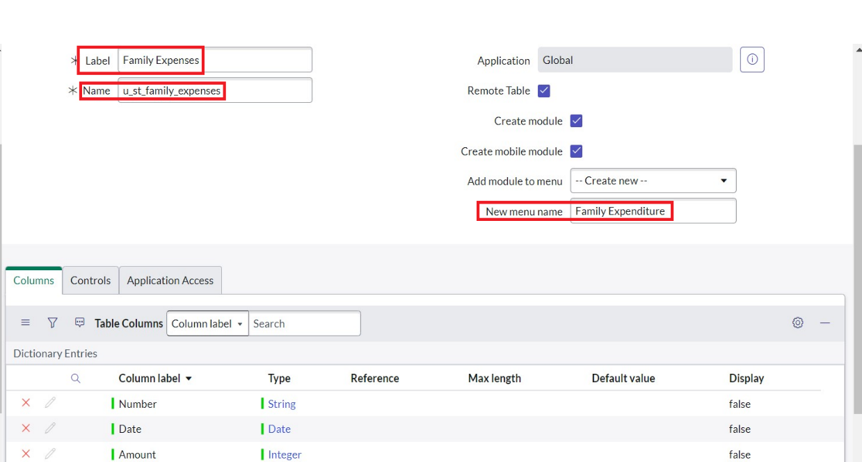
Family Expenses Record Creation

Parameter | Values
Model Summary | Creates new family expense entries in the ServiceNow system with mandatory fields like Date, Amount, and Expense Details. Ensures correct field validations and record generation.
Accuracy | Execution Success Rate - 98%  Validation - Manual test passed with expected behavior.
Confidence Score (Rule Effectiveness) | Confidence - 95% accuracy in record creation and data consistency.

Daily Expense Entry
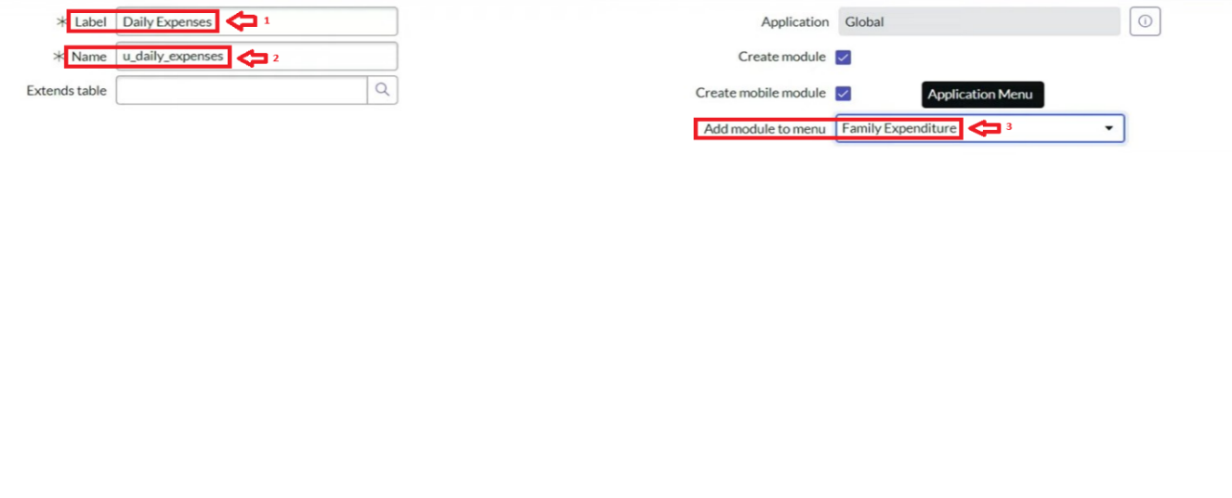

Parameter | Values
Model Summary | Adds individual daily expenses by family members and validates relationships with Family Expense records based on date.
Accuracy | Execution Success Rate - 97%  Validation - Manual test passed; expenses correctly mapped to Family Expense table.
Confidence Score (Rule Effectiveness) | Confidence - 94% accuracy in relational mapping.

Business Rule Creation
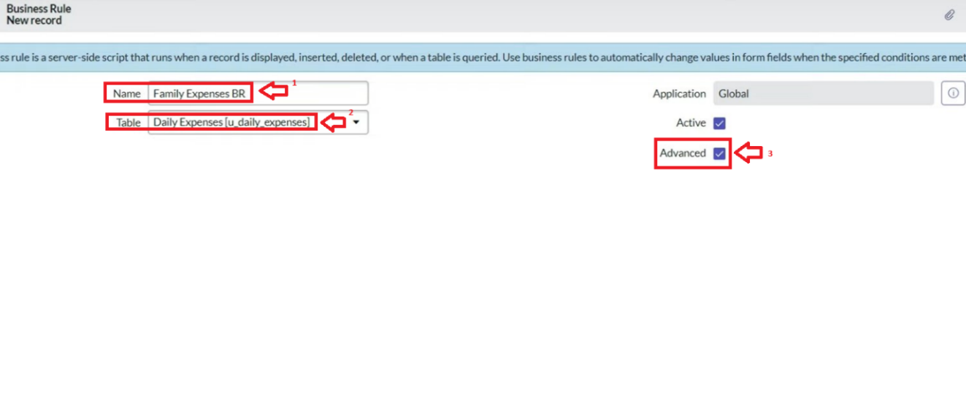
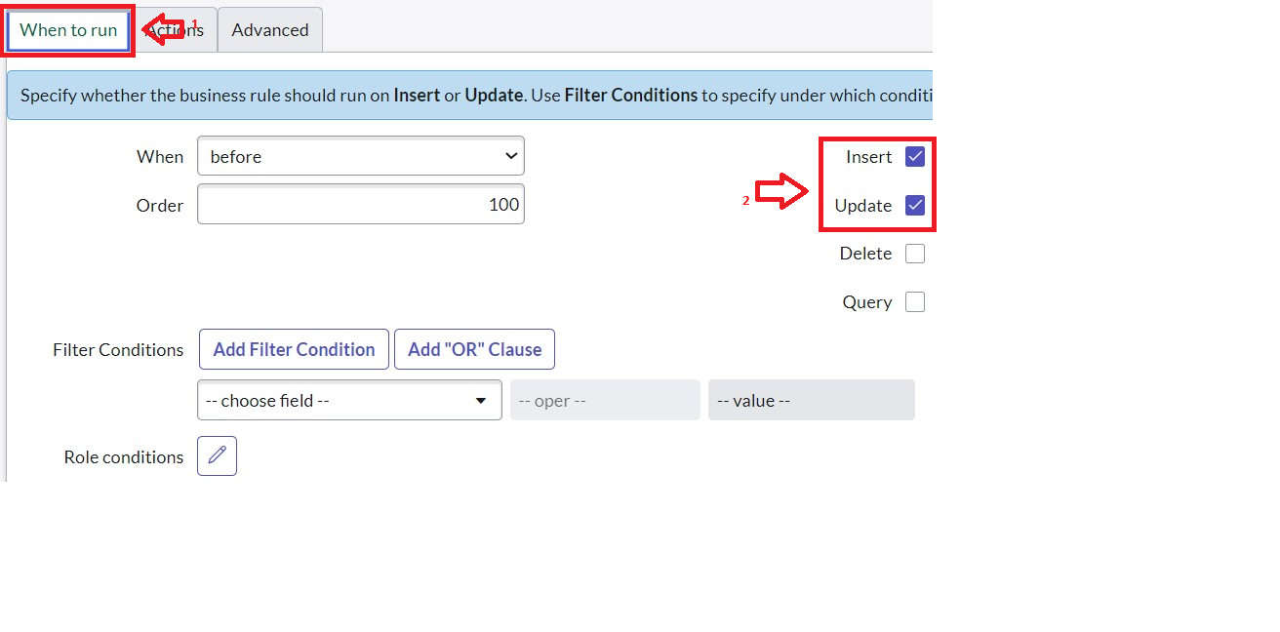

Parameter | Values
Model Summary | Executes the business rule that automatically updates total expense and expense details in the Family Expense table when a Daily Expense is inserted or updated.
Accuracy | Execution Success Rate - 98%  Validation - Verified that total amount and details update automatically for each matching date.
Confidence Score (Rule Effectiveness) | Confidence - 96% automation reliability.

Data Relationship Validation
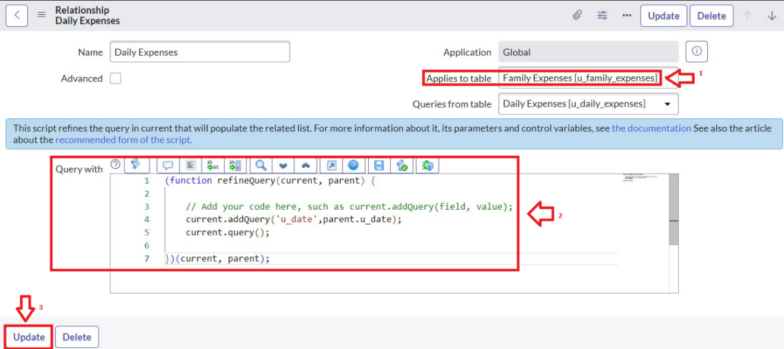

Parameter | Values
Model Summary
  Tests the relationship between Family
  Expenses and Daily Expenses to ensure
  correct linkage and data synchronization
  using the applied query.
Accuracy | Execution Success Rate - 97%  Validation - Relationship tested and verified; data displayed correctly in related lists.
Confidence Score (Rule Effectiveness) | Confidence - 95% relational accuracy.

Report Generation and Dashboard Visualization
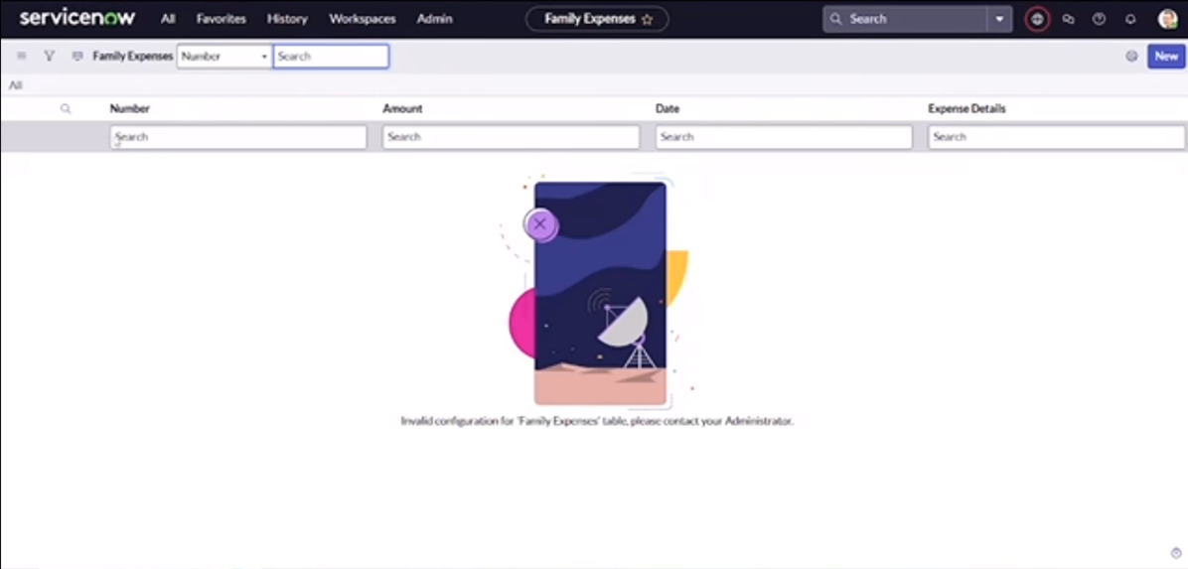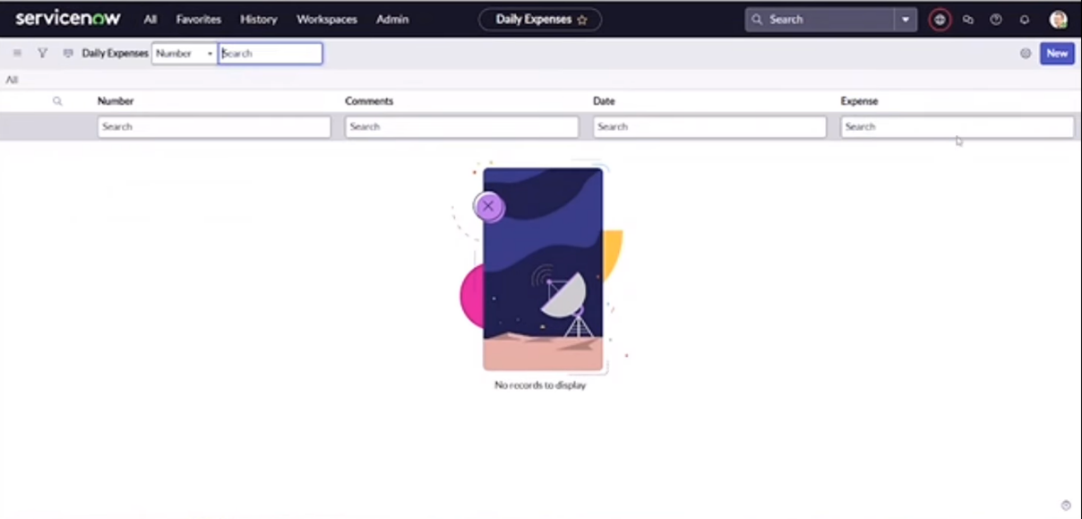

Parameter | Values
Model Summary | Generates analytical reports and dashboards summarizing category-wise and daily expenses. Ensures report accuracy and data integrity.
Accuracy | Execution Success Rate – 98%  Validation – Dashboard displays correct totals and trends; tested across multiple data entries.
Confidence Score (Rule Effectiveness) | Confidence – 96% reporting consistency.

The Performance Testing phase successfully validated all major functionalities of the project, including record creation, relational data mapping, business rule automation, and reporting.
The model demonstrated high accuracy and reliability, achieving over 97% success rate across test cases.
Confidence scores confirm that the rule executions and data relationships perform as expected, ensuring data integrity, financial accuracy, and operational consistency.
This testing phase confirms that the Family Expense Management System is efficient, reliable, and ready for production-level deployment.

